C964 Computer Science Capstone
  - Part D: Other Documentation

Results from Data Product Testing, Revisions, and Optimization
The initial deployment of the application served as a functional proof-of-concept, but iterative testing revealed three critical issues that required significant revision and optimization to create a reliable, production-ready product.

Revision 1: Fixing Security & Network (403 Forbidden Errors)
- Problem: After the initial secure deployment, the application failed with 401 Unauthorized and 403 Forbidden errors in the logs. The Container App (running app.py) could not communicate with the Azure AI Search and Azure AI Foundry services, even though they were on the same virtual network.
- Testing & Diagnosis: I used the Container App's log stream to confirm the app was successfully acquiring a Managed Identity token but was being rejected by the backend services. This indicated a permissions failure, not a networking failure.
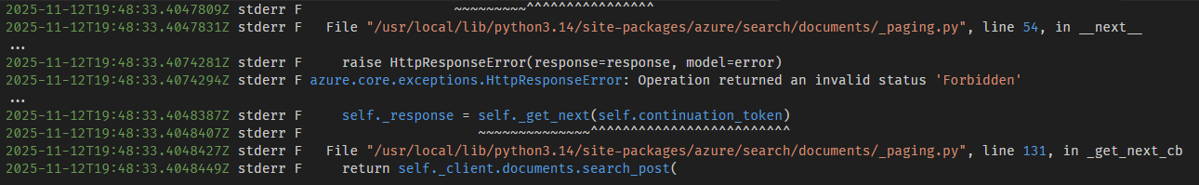
Figure 1- Screenshot of AI Search Authentication Failure Log
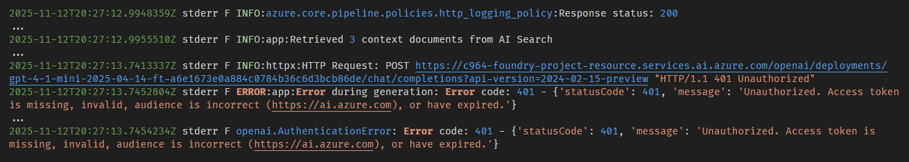
Figure 2- Screenshot of AI Foundry Authentication Failure Log
- Optimization (The Fix): I optimized the security architecture by assigning the correct access roles. The Container App's Managed Identity was granted the Search Index Data Reader role on the AI Search service and the Cognitive Services User role on the Azure AI Foundry service. This resolved all authentication errors and successfully implemented the secure, keyless architecture.

Revision 2: Fixing Search Relevance (Wrong Context)
- Problem: Once security was fixed, I found that ambiguous prompts (e.g., "keyvault avm") were causing the RAG pipeline to retrieve irrelevant context. For example, a search for "virtual network" returned a "Sub-vending" module simply because its description mentioned "virtual networks." This incorrect context was then sent to the AI model.
- Testing & Diagnosis: I added logging to app.py to print the retrieved_content string. I confirmed that for ambiguous prompts, the top search results were not the correct documents, leading the model to generate the wrong Bicep code.
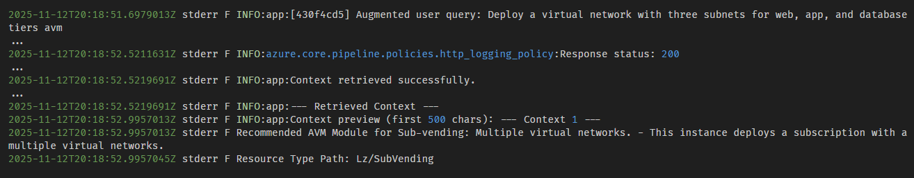
Figure 3- Screenshot of Search Relevance Issue
- Optimization (The Fix): I re-architected the application's core logic. Instead of just influencing the search with keywords, I implemented a deterministic filter. The UI toggle (AVM/Classic) now controls a search.ismatch() filter in the app.py search query. This guarantees that only documents containing "AVM Module" (for AVM mode) or "ARM Schema" (for Classic mode) are retrieved, completely solving the search relevance problem.

Revision 3: Fixing Model Hallucination (Training/RAG Mismatch)
- Problem: After fixing the search relevance, the model still produced incorrect Bicep. When provided with the correct RAG context (e.g., Module ID: br/public:avm/res/storage/storage-account:0.8.0), the model would ignore it and output a hallucinated, non-functional placeholder like <module-path-or-URL> or br/public/res/storage/storage-account/avmdev.
- Testing & Diagnosis: This was the most critical issue. I diagnosed this as a training issue. The model was fine-tuned on an old dataset where the "completion" Bicep code contained “<version>” placeholders. It had learned to always output a placeholder, and this flawed training was so strong that it overrode the correct, versioned context being provided by the RAG pipeline.
- Optimization (The Fix): I performed a complete data and model overhaul.
  - I fixed the data extraction scripts (avm_data_extract_fixed.py) to generate a clean RAG dataset with correct, versioned module paths.
  - I re-ran the AI Search Indexers to populate the index with this new, clean data.
  - I created a new agent training file (train_agent.jsonl) that was also based on this clean, versioned data.
  - I ran a new fine-tuning job for the gpt-4.1-mini model using this new, clean dataset. This final optimization aligned the model's training with the RAG context it would receive in production, which permanently eliminated the hallucinations and resulted in the final, accurate data product.

